Game Project 1

<Mastermind Game>

CSC 5- 41202

Heidy Tamayo

Date: 02/02/16

**Introduction**

Title: Mastermind Game

Mastermind is played online where there is a table showing four empty slots allowing the user to enter a round marble color. The colors to choose from are red, blue, black, green, white, orange, brown and yellow. The computer generates its own colors and the user must guess which colors the computer has picked. The user types in the color in order from left to right and is then told if they have made a wrong guess. The user is then asked if they would like a hint. If yes, the program gives a hint indicating if one of the colors is in the correct spot if not it goes on to the next try for the user to guess the colors. The user can keep guessing the colors the computer has generated up to the end of the tenth try or if the user guesses all the colors correctly. If the user cannot guess the colors, the message displays they have lost the game. If the user has won, the percent accuracy is generated along with the number of tries it took the user to complete the game. At the end of the game whether win or lose, the computer asks the user if they would like to play again or end the program.

**Summary**

Project size: 276 lines

The number of variables: about 23

The number of concepts used: 13

I tried to make the mastermind game as it was shown online. However, I couldn’t figure out to show the multiple inputs the user put without having it override once a new turn began. I used what was require and didn’t really go try the new concepts we have learned in class such as functions. The project is complete but hope to learn new concepts where I can allow the user to see previous inputs they have inputted in the program to allow them to determine the colors the computer generates. Perhaps the most difficult was trying to start the program where the computer generate strings of the colors as compared with just having the computer generate a character. This took about a week from start to finish since I used examples I had previously worked on.

**Description**

The main point of the program is to have the user think through the game based on the hints the computer generates and allow the user to guess the colors the computer has generated randomly.

**Flowchart**

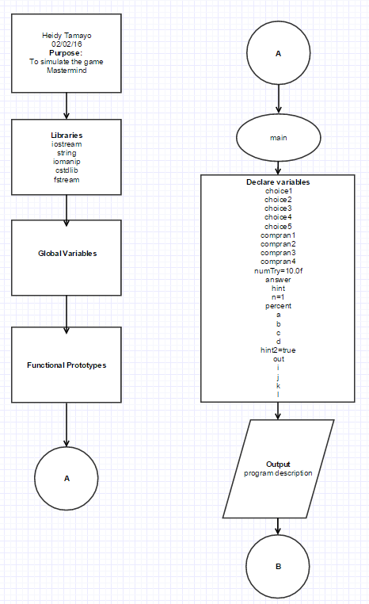

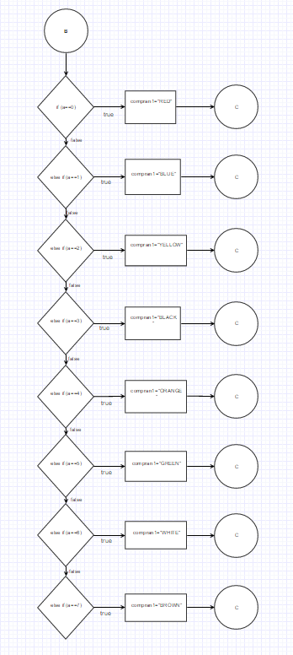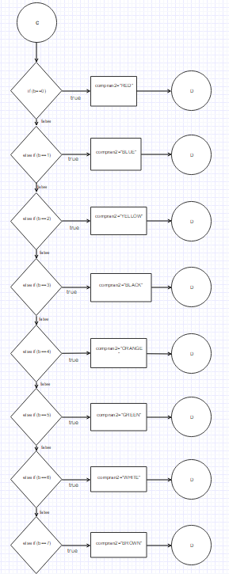

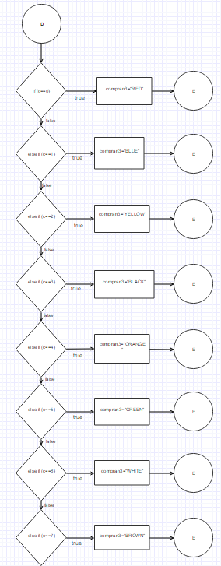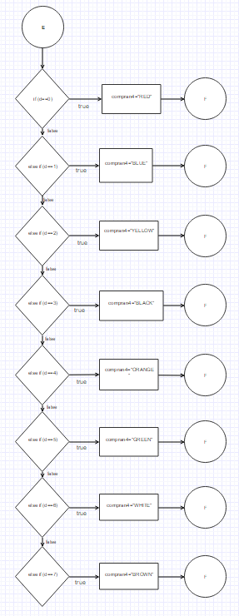

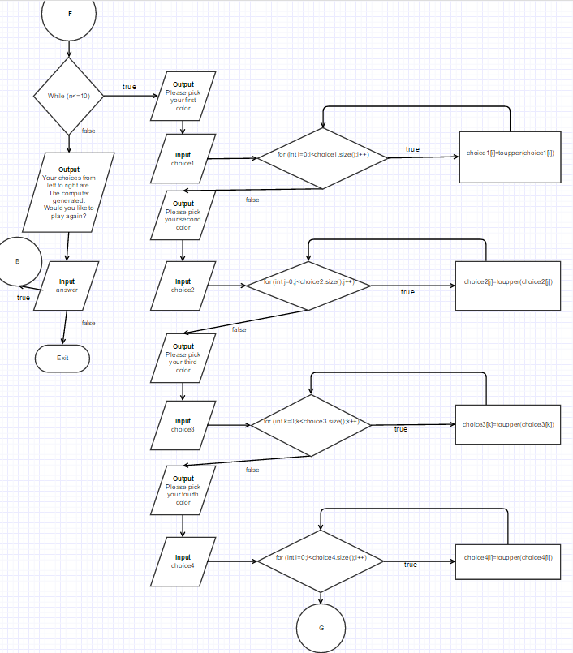

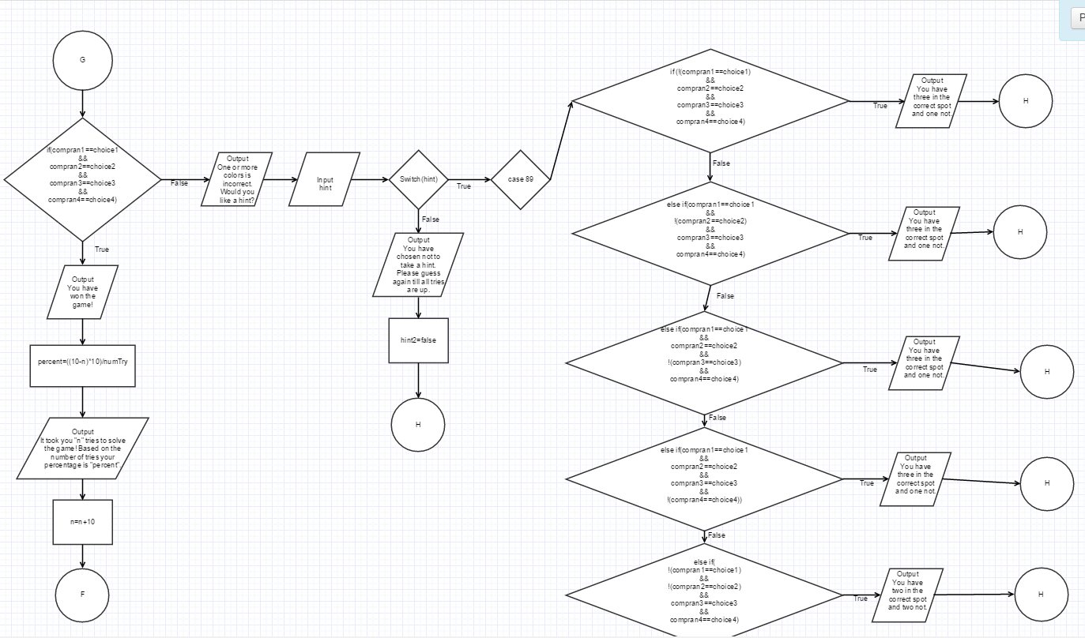

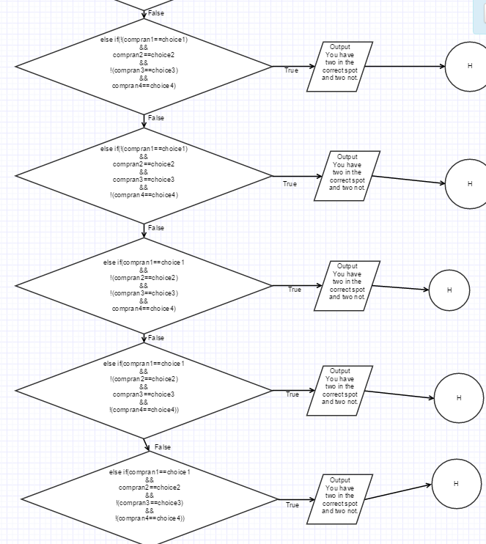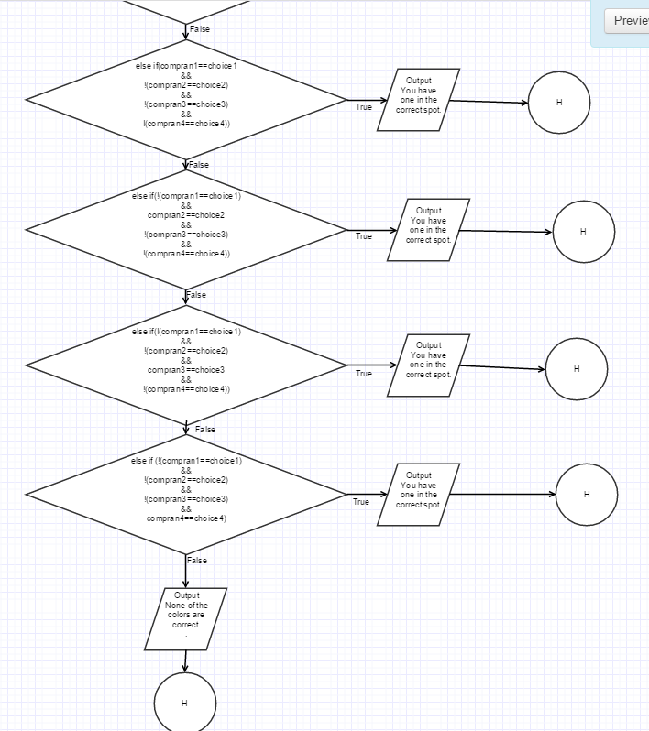

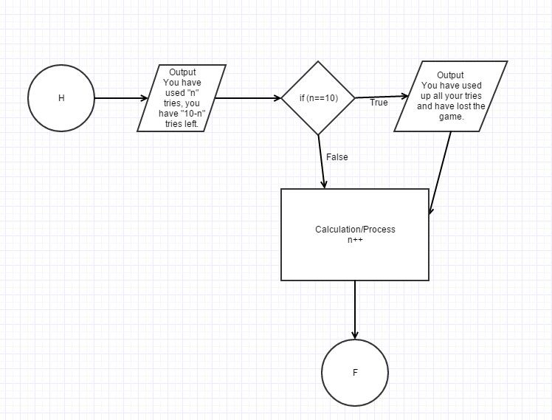

**Major Variables**

|  |  |  |  |
| --- | --- | --- | --- |
| **Type** | **Variable Name** | **Description** | **Location** |
| int | a | Determining the first color by the computer | int main(int argc, char** argv) |
|  | b | Determining the second color by the computer | int main(int argc, char** argv) |
|  | c | Determining the third color by the computer | int main(int argc, char** argv) |
|  | d | Determining the fourth color by the computer | int main(int argc, char** argv) |
|  | i | Integer to allow the input color to be lowercase or uppercase | In for loop |
|  | j | Integer to allow the input color to be lowercase or uppercase | In for loop |
|  | k | Integer to allow the input color to be lowercase or uppercase | In for loop |
|  | l | Integer to allow the input color to be lowercase or uppercase | In for loop |
| char | numTry=10.0f | The number of tries the user is allowed | In if else statement |
|  | answer | The answer the user inputs if they want to play again | In do while loop |
|  | hint | Choice of whether the user would like a hint | In switch statement |
| float | n=1 | Increment start of the number of tries | In while loop |
|  | percent | The calculation of percent accuracy once the user wins the game | In if else statement |
| string | choice1 | The first color the user inputs | int main(int argc, char** argv) |
|  | choice2 | The second color the user inputs | int main(int argc, char** argv) |
|  | choice3 | The third color the user inputs | int main(int argc, char** argv) int main(int argc, char** argv) |
|  | choice4 | The fourth color the user inputs | int main(int argc, char** argv) |
|  | compran1 | The first color the computer generates | int main(int argc, char** argv) |
|  | compran2 | The second color the computer generates | int main(int argc, char** argv) |
|  | compran3 | The third color the computer generates | int main(int argc, char** argv) |
|  | compran4 | The fourth color the computer generates | int main(int argc, char** argv) |
| bool | hint2=true | The hint that is generated if the statement is true | In switch statement |
| ofstream | out | File of program | int main(int argc, char** argv) |

Program

/*

* File: main.cpp

* Author: Heidy Tamayo

* Created on January 29, 2016, 5:15 PM

* Purpose: To simulate the game Mastermind

*/

//System Libraries

#include <iostream> //I/O

#include <string> //string

#include <iomanip> //Formatting

#include <cstdlib> //srand and rand function

#include <fstream> //File I/O

using namespace std;

//User Libraries

//Global Constants

//Functional Prototypes

//Execution Begins Here

int main(int argc, char** argv) {

//Declare and initialize variable

string choice1, choice2, choice3, choice4;//The 4 colors the user chooses

string compran1, compran2, compran3, compran4;//The 4 colors the computer generates

char numTry=10.0f;//The number of tries the user gets

char answer, hint;//The response of whether the user would like to play again or take a hint

float n=1, percent;//The intervals of the turns, the percentage of the accuracy

int a,b,c,d;//The variables that generate the random colors for the computer

bool hint2=true;

ofstream out;

//Open the file

out.open("MastermindProject.dat");

//Do while loop to see if the user would like to play again

do

{

//Output description

cout<<"This program will run the game known as Mastermind where you are given"<<endl;

cout<<"10 chances to guess the 4 colors the computer picked randomly. The order"<<endl;

cout<<"of the colors also matters in this game."<<endl;

cout<<"Your color choices are red, blue, green, brown, white, black, orange, and yellow."<<endl;

srand (time(NULL));

//Determining first color by the computer

a=rand() % 6;

{

if (a==0) {

compran1="RED";

}

else if (a==1) {

compran1="BLUE";

}

else if (a==2) {

compran1="YELLOW";

}

else if (a==3) {

compran1="BLACK";

}

else if (a==4) {

compran1="ORANGE";

}

else if (a==5) {

compran1="GREEN";

}

else if (a==6){

compran1="WHITE";

}

else if (a==7){

compran1="BROWN";

}

}

//Determining the second color by the computer

b=rand() % 6;

{

if (b==0) {

compran2="RED";

}

else if (b==1) {

compran2="BLUE";

}

else if (b==2) {

compran2="YELLOW";

}

else if (b==3) {

compran2="BLACK";

}

else if (b==4) {

compran2="ORANGE";

}

else if (b==5) {

compran2="GREEN";

}

else if (b==6){

compran2="WHITE";

}

else if (b==7){

compran2="BROWN";

}

}

//Determining the third color by the computer

c=rand() % 6;

{

if (c==0) {

compran3="RED";

}

else if (c==1) {

compran3="BLUE";

}

else if (c==2) {

compran3="YELLOW";

}

else if (c==3) {

compran3="BLACK";

}

else if (c==4) {

compran3="ORANGE";

}

else if (c==5) {

compran3="GREEN";

}

else if (c==6){

compran3="WHITE";

}

else if (c==7){

compran3="BROWN";

}

}

//Determining the fourth color by the computer

d=rand() % 6;

{

if (d==0) {

compran4="RED";

}

else if (d==1) {

compran4="BLUE";

}

else if (d==2) {

compran4="YELLOW";

}

else if (d==3) {

compran4="BLACK";

}

else if (d==4) {

compran4="ORANGE";

}

else if (d==5) {

compran4="GREEN";

}

else if (d==6){

compran4="WHITE";

}

else if (d==7){

compran4="BROWN";

}

}

numTry=numTry<n?numTry:n;//Ternary operator

//While loop to only allow the user ten tries

while(n<=10)

{

//Output request the user to enter the 4 colors

cout<<"Please pick your first color you would want displayed going from"<<endl;

cout<<"left to right."<<endl;

cin>>choice1;

//For loop in order to allow the user to enter the color in lowercase or uppercase

for (int i=0;i<choice1.size();i++){

choice1[i]=toupper(choice1[i]);

}

cout<<"The second color."<<endl;

cin>>choice2;

for (int j=0;j<choice2.size();j++){

choice2[j]=toupper(choice2[j]);

}

cout<<"The third color."<<endl;

cin>>choice3;

for (int k=0;k<choice3.size();k++){

choice3[k]=toupper(choice3[k]);

}

cout<<"The fourth color."<<endl;

cin>>choice4;

for (int l=0;l<choice4.size();l++){

choice4[l]=toupper(choice4[l]);

}

//if else statement to determine if the user has won or needs hints

if(compran1==choice1&&compran2==choice2&&compran3==choice3&&compran4==choice4)

{

//Output of results

cout<<fixed<<setprecision(1)<<showpoint;

cout<<endl<<"You have won the game!"<<endl;

percent=((10-n)*10)/numTry;

cout<<"It took you "<<n<<" tries to solve the game! Based on your number of tries, your";

cout<<" percentage is "<<percent<<"% accuracy!"<<endl;

n=n+10;

}

else

{

cout<<"One or more colors is incorrect. Would you like a hint? Type y for yes."<<endl;

cin>>hint;

hint=toupper(hint);

//Switch statement to determine if the user would like a hint

switch (hint)

{

case 89:

{

//else if statements to determine which hint will be outputted

if (!(compran1==choice1)&&compran2==choice2&&compran3==choice3&&compran4==choice4){

cout<<"You have three in the correct spot and one not."<<endl;}

else if(compran1==choice1&&!(compran2==choice2)&&compran3==choice3&&compran4==choice4){

cout<<"You have three in the correct spot and one not."<<endl;}

else if(compran1==choice1&&compran2==choice2&&!(compran3==choice3)&&compran4==choice4){

cout<<"You have three in the correct spot and one not."<<endl;}

else if(compran1==choice1&&compran2==choice2&&compran3==choice3&&!(compran4==choice4)){

cout<<"You have three in the correct spot and one not."<<endl;}

else if(!(compran1==choice1)&&!(compran2==choice2)&&compran3==choice3&&compran4==choice4){

cout<<"You have two in the correct spot and two not."<<endl;}

else if(!(compran1==choice1)&&compran2==choice2&&!(compran3==choice3)&&compran4==choice4){

cout<<"You have two in the correct spot and two not."<<endl;}

else if(!(compran1==choice1)&&compran2==choice2&&compran3==choice3&&!(compran4==choice4)){

cout<<"You have two in the correct spot and two not."<<endl;}

else if(compran1==choice1&&!(compran2==choice2)&&!(compran3==choice3)&&compran4==choice4){

cout<<"You have two in the correct spot and two not."<<endl;}

else if(compran1==choice1&&!(compran2==choice2)&&compran3==choice3&&!(compran4==choice4)){

cout<<"You have two in the correct spot and two not."<<endl;}

else if(compran1==choice1&&compran2==choice2&&!(compran3==choice3)&&!(compran4==choice4)){

cout<<"You have two in the correct spot and two not."<<endl;}

else if(compran1==choice1&&!(compran2==choice2)&&!(compran3==choice3)&&!(compran4==choice4)){

cout<<"You have one in the correct spot."<<endl;}

else if(!(compran1==choice1)&&compran2==choice2&&!(compran3==choice3)&&!(compran4==choice4)){

cout<<"You have one in the correct spot."<<endl;}

else if(!(compran1==choice1)&&!(compran2==choice2)&&compran3==choice3&&!(compran4==choice4)){

cout<<"You have one in the correct spot."<<endl;}

else if (!(compran1==choice1)&&!(compran2==choice2)&&!(compran3==choice3)&&compran4==choice4){

cout<<"You have one in the correct spot."<<endl;}

else{

cout<<"None of the colors are correct."<<endl;}

break;

}

default:

{

cout<<"You have chosen not to take a hint. Please guess again till your number of tries is up."<<endl;

hint2=false;

}

}

cout<<endl<<"You have used up "<<n<<" tries, you have "<<10-n<<" tries left."<<endl<<endl;

if (n==10)

{

//Output of results after all tries have been used up

cout<<"You have used all your tries and have lost the game."<<endl<<endl;

}

n++;

}

}

//Output of results

cout<<"Your choices from left to right are "<<choice1<<" "<<choice2<<" "<<choice3<<" "<<choice4<<endl;

cout<<"The computer's choices from left to right are "<<compran1<<" "<<compran2<<" "<<compran3<<" "<<compran4<<endl;

cout<<endl<<"Would you like to play again?"<<endl;

cin>>answer;

cout<<endl;

answer=toupper(answer);

n=1;

}while(answer=='Y');

//Exit stage right

out.close();

return 0;

}